Trevor McLaurine

6/27/2023

Assignment 6.2 – Aggregate Queries

2. Show documents in houses collection

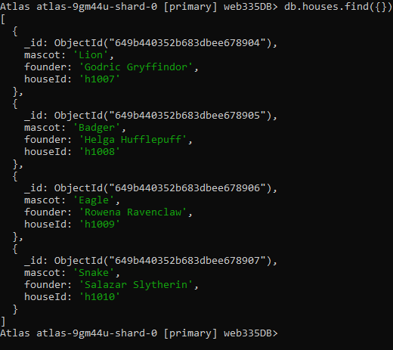

3. Show documents from the students collection

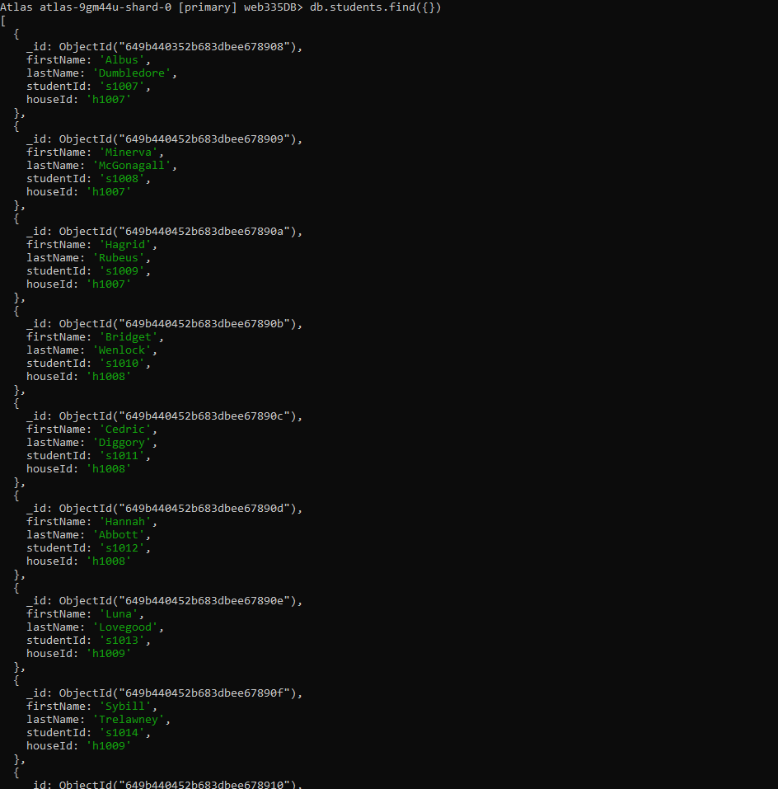

4. Add new student and show that it was added.

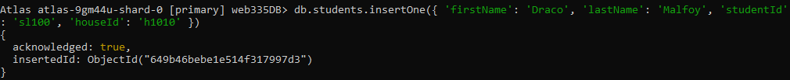

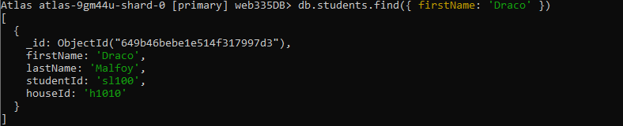

5. Delete student previously created



6. Shows students by house

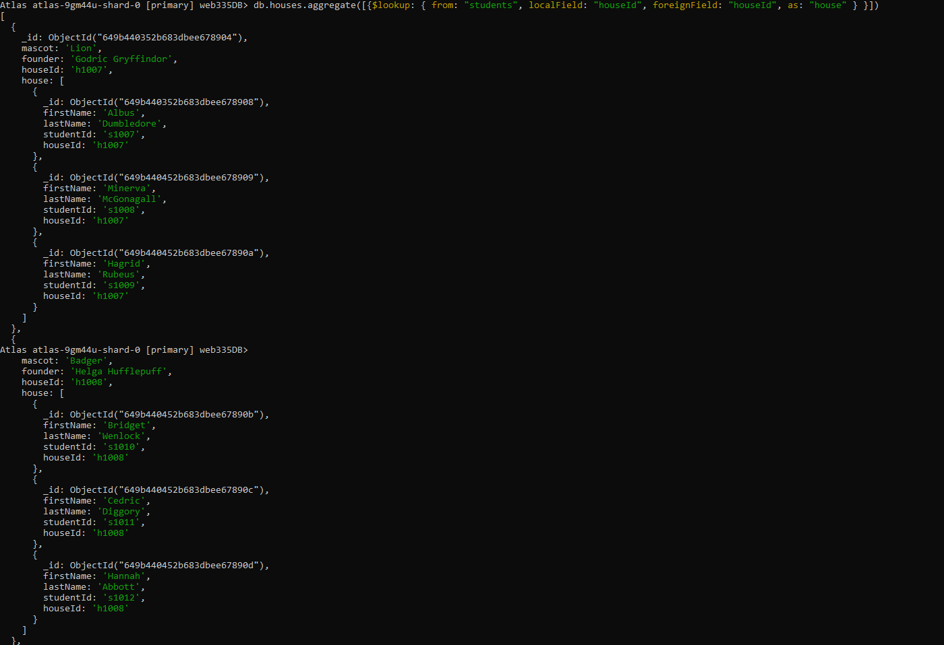

7. Gryffindor

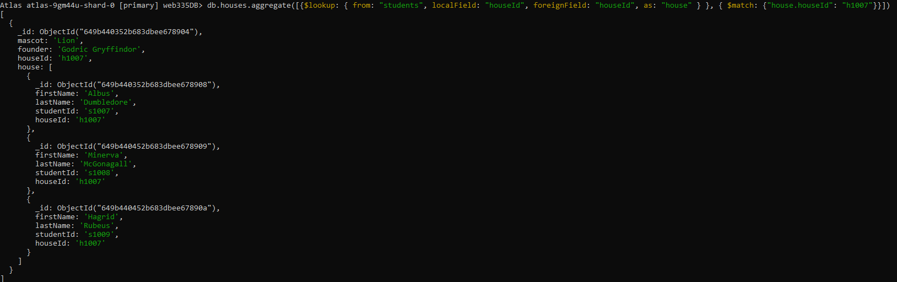

8. Eagle

